Table Of Contents

Topic | Page No.
1. Installation Process | 2
2. EKC Features | 3

1. Installation Process
- Create a Package.
  - Go to setup -> Package Manager -> Select package
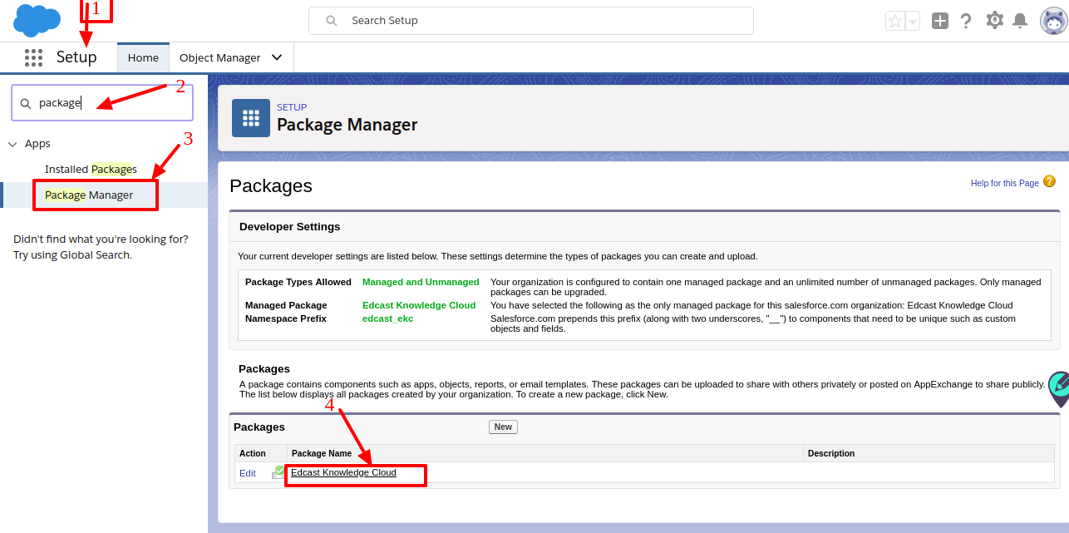
  - Add components and then click on upload.
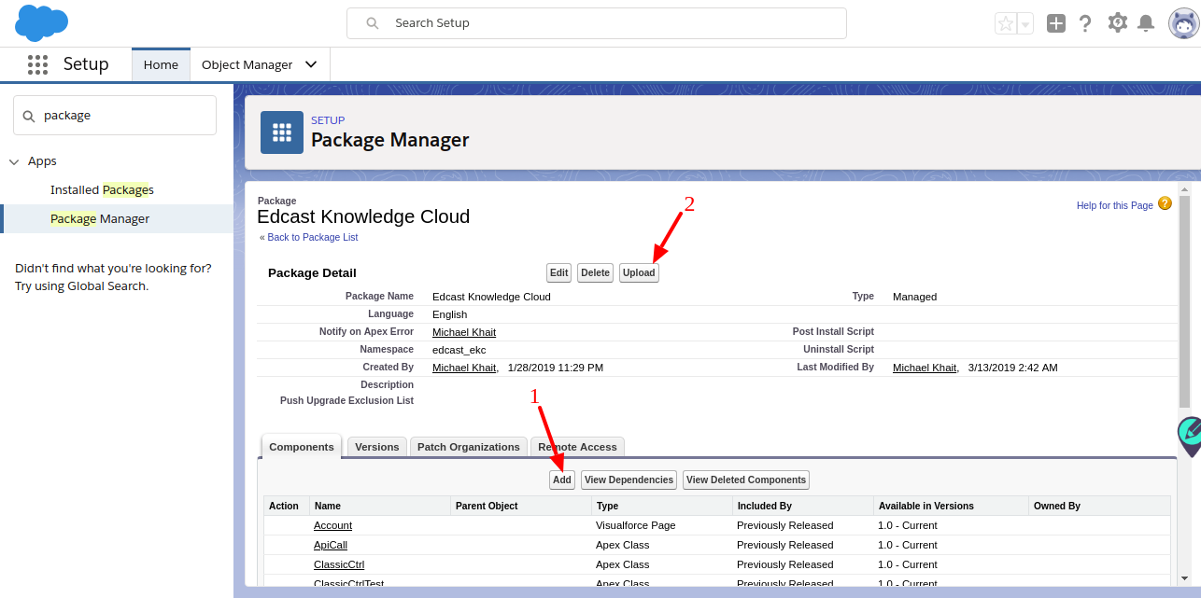
- Package installation.
  - Copy the ‘Package’ link and open the link in a new browser window.
  - Using Salesforce login credentials select the org on which you want to install the package.
  - Select ‘Installation Profile’ and then click on ‘Install’.
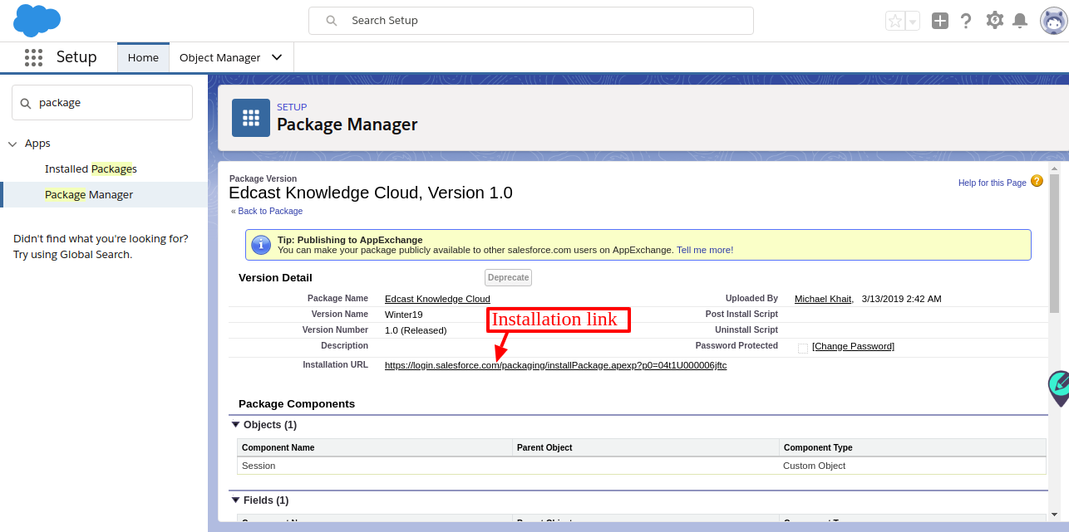

2. EKC features
- Today’s Insight
  - Targeted Smartcards that focus on individual user learning goals.
  - Updated every 24 hours.

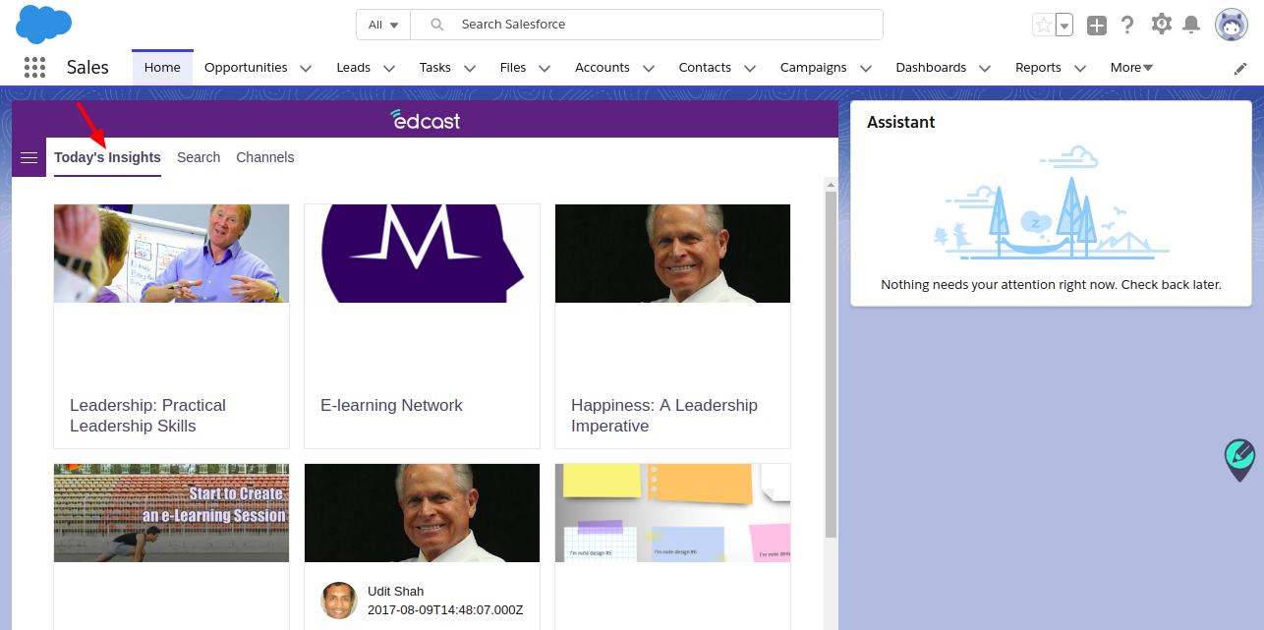
- Search
  - Users can search cards using the search functionality.
  - Cards are added initially according to the selected value of the object’s name field.
    - Passing the name field value to the search API to load the cards according name field value.
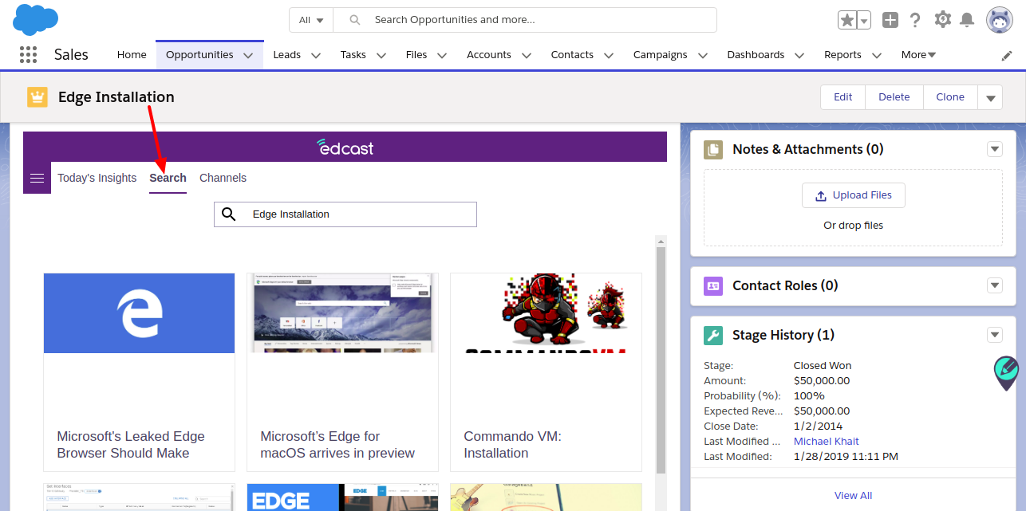
- Channels
  - Cards can also be loaded according to Channels.
  - Click on ‘Channel’ to review the list of all available channels.
    - After loading all the Channels, users can load Channel- specific cards into the appropriate Channel.
